

# Driver Drowsiness Detection System

Submitted in partial fulfillment of the requirements of the course Innovative Product Development under

**T. Y. B. Tech. Computer Science and Engineering (Data Science)**

By

**Rishabh Patil 60009200056**

**Saksham Jha** **60009200070**

Guide

**Mrs. Pooja Vartak**

Designation

University of Mumbai 2021-2023

**CERTIFICATE**

This is to certify that the project entitled **“Driver Drowsiness Detection System”** is a bonafide work of **Rishabh Patil 60009200056, Saksham Jha 60009200070** submitted to the **Department of Computer Science and Engineering (Data Science)** in partial fulfillment of the requirement for the course of Innovative Product Development.

------------------------------------------- ---------------------------------------

| **(Prof. Kanchan Dabre)**  **Internal Guide** | **(Dr. Kriti Srivastava)**  **Head of the Department** |
| --- | --- |

----------------------------

**(Dr. Hari Vasudevan)**

**Principal**

## Project Report Approval for Innovative Product Development.

This project report entitled ***Driver Drowsiness Detection System*** by ***Rishabh Patil 60009200056, Saksham Jha 60009200070,*** is approved for the course of Innovative Product Development***.***

Examiners

1. _________________________

2.__________________________

Date: 10/5/23

Place: Mumbai

## Declaration

I/We declare that this written submission represents my/our ideas in my/our own words and where others' ideas or words have been included, we have adequately cited and referenced the original sources. We also declare that We have adhered to all principles of academic honesty and integrity and have not misrepresented or fabricated or falsified any idea/data/fact/source in our submission. We understand that any violation of the above will be cause for disciplinary action by the Institute and can also evoke penal action from the sources which have thus not been properly cited or from whom proper permission has not been taken when needed.



**Rishabh Patil (60009200056)**



**Saksham Jha (60009200070)**

Date: 10/5/23

## Acknowledgement

I would like to express my deepest gratitude and appreciation to all the individuals and organizations who have contributed to the successful completion of this driver drowsiness detection project.

First and foremost, I would like to thank my project supervisor, Prof Pooja Vartak, Dr Kriti Srivastav, Prof Kanchan Dabre and Prof Pradnya Saval for their invaluable guidance, support, and expertise throughout this project. Their constant encouragement and insightful feedback have been instrumental in shaping the direction of this research and ensuring its successful execution.

I would also like to extend my heartfelt thanks to the faculty members of Dwarkadas Jivanlal Sanghvi College of Engineering, whose teachings and knowledge have provided a strong foundation for this project. Their dedication to imparting quality education and fostering an environment of intellectual growth has been truly inspiring.

I am grateful to the participants who willingly volunteered their time and cooperation for data collection, as their involvement has been crucial in obtaining accurate and meaningful results. Their contribution to this project is highly appreciated.

Lastly, I would like to thank my family and friends for their unwavering support and understanding throughout this project. Their encouragement, patience, and belief in my abilities have been a constant source of motivation.

In conclusion, this project would not have been possible without the collective efforts, support, and contributions of all the individuals mentioned above. I am truly grateful for their involvement and for being a part of this journey towards improving driver safety through drowsiness detection.

## Abstract

The proposed driver drowsiness detection project aims to address the critical issue of drowsiness and fatigue, which are major causes of road accidents. This project acknowledges the importance of preventing accidents by detecting and alerting drivers who are experiencing drowsiness while driving. The traditional methods for drowsiness detection, such as EEG and ECG, though accurate, have limitations in terms of real-time monitoring and comfort for drivers.

To overcome these limitations, the project introduces a novel approach that utilizes the measurement of eye closing rate and yawning to identify signs of drowsiness in drivers. The methodology involves analyzing video or image data to detect and track the driver's eyes and mouth, which are key areas indicating drowsiness. By narrowing down the analysis to the face region, the system can accurately locate the eyes and mouth within the captured video or image.

The system then focuses on locating the eyes and mouth within the face area, using specialized algorithms and parameters specifically designed for these regions of interest. By extracting features from the eye and face areas, the system can determine whether the eyes are open or closed and calculate the yawn score.

When the system identifies closed eyes or persistent yawning over a certain number of frames, it confirms that the driver is in a drowsy state. In such cases, an alarm is raised to alert the driver, ensuring their attention is regained and potential accidents are prevented.

This project recognizes the significance of real-time monitoring and the need for a non-intrusive approach to drowsiness detection. By utilizing computer vision techniques and image processing algorithms, it provides an efficient and effective solution that can be implemented in real-world driving scenarios.

## Table of Contents

| **Chapter** | **Contents** | **Page No.** |
| --- | --- | --- |
| **I** | **Introduction** | **10** |
|  | **1.1 Aim of the Project** | **10** |
|  | **1.2 Motivation** | **10** |
|  | **1.3 Organization of Report** | **11** |
| **II** | **Literature Survey** | **12** |
| **III** | **Problem Description** | **17** |
|  | **3.1 Problem Statement** | **17** |
|  | **3.2 Scope of the Project** | **17** |
| **IV** | **Proposed Design** | **19** |
| **V** | **Results and Discussions** | **20** |
| **VI** | **Conclusion** | **23** |
| **VII** | **References** | **24** |

**List of Figures**

| **Fig. No.** | **Figure Caption** | **Page No.** |
| --- | --- | --- |
| 1 | Proposed Design | 19 |
| 2 | Architectural Design |  |
| 2 | Driver Yawning | 20 |
| 3 | Driver Laughing | 20 |
| 4 | Driver with Shades | 21 |
| 5 | Driver with Glasses | 21 |
| 6 | Driver along with Passenger yawning | 22 |

## List of Abbreviations

| **Sr. No.** | **Abbreviation** | **Expanded form** |
| --- | --- | --- |
| i | GPU | Graphics Processing Unit |
| ii | YOLO | You Only Look Once |
| iii | SVM | Support Vector Machine |
| iv | SGD | Stochastic Gradient Descent |
| v | SWA | Steering Wheel Angle |
| vi | LDA | Linear Discriminant Analysis |
| vii | CNN | Convolutional Neural Network |
| viii | RNN | Recurrent Neural Network |
| ix | ANN | Artificial Neural Network |
| x | LDA | Linear Discriminant Analysis |
| xi | KNN | K Nearest Neighbours |



**Chapter 1. INTRODUCTION**

### Aim of the Project

Driver drowsiness and fatigue are one of the most common reasons for accidents. The number of fatalities due to such accidents is increasing worldwide each year. The report aims to lessen the number of accidents due to driver drowsiness and fatigue. This will in turn increase transportation safety. Driver drowsiness detection is a technology in vehicles that is useful in preventing accidents and saving the lives of drivers when they are getting drowsy. The project uses computer vision for the detection of drivers’ drowsiness. and aims to contribute to reducing the number of accidents caused by drowsy driving, thereby enhancing road safety and saving lives. The developed driver drowsiness detection system can serve as a valuable tool to assist drivers in staying alert and preventing potential accidents resulting from driver fatigue.

### Motivation

Regardless of social status, there are rules and codes of conduct that apply to all drivers. One crucial aspect is the need to remain alert and attentive while operating a vehicle. Neglecting these responsibilities towards safe travel has resulted in countless accidents each year. Although some may perceive these rules as insignificant, adhering to them is of utmost importance.On the road, an automobile possesses significant power, and when placed in the hands of irresponsible individuals, it can lead to accidents that affect the lives of everyone in and around the vehicle. Disregarding one's tired state as a driver is a form of carelessness. Recognizing the potential for devastating consequences, many researchers have dedicated their efforts to developing driver drowsiness detection systems. However, there are instances where the accuracy of these systems' observations and findings falls short.Therefore, the purpose of this paper is to provide an alternative perspectives on this pressing issue. It aims to improve the implementation of driver drowsiness detection systems by enhancing their accuracy and optimizing their effectiveness. The goal is to contribute to the ongoing efforts to address this problem and promote safer driving practices

### Organization of Report

This report describes the entire system in chapters as follows:

Chapter 2: Review of Literature

This chapter includes area of research in Driver drowsiness detection aimed at improving road safety and preventing accidents caused by fatigued drivers. Over the years, numerous studies have been conducted to develop effective methods and systems for detecting drowsiness in drivers.

Chapter 3: Problem Description

This chapter talks about Driver drowsiness detection using YOLOv5 as a specific approach that leverages the YOLOv5 architecture to address the problem of drowsy driving. The system aims to detect and alert drivers when they show signs of drowsiness, allowing them to take necessary actions to prevent accidents

Chapter 4:Proposed Design

The project focuses on driver drowsiness detection using either images or video streams. The input undergoes preprocessing, including resizing, Gaussian blur, and face alignment. Regions of interest like the mouth and eyes are extracted and analyzed using the YOLOv5 Model. Based on the model's predictions, an alarm is triggered if drowsiness is detected. This process is repeated for each frame in a video stream

## Chapter 2. LITERATURE SURVEY

Authors Xiao, Bao, and Yan propose a novel approach for detecting yawning behavior. The authors utilize Gabor wavelets, a type of mathematical function, to extract relevant features from facial images. These features are then fed into a classification algorithm called Linear Discriminant Analysis (LDA) to differentiate between yawning and non-yawning instances. [1]

Authors Yin, Fan, and Sun proposes a driver fatigue detection system that utilizes multiscale dynamic features. The authors propose a method that captures and analyzes various temporal scales of driver behavior, enabling the detection of subtle fatigue-related changes. By extracting and combining these dynamic features, such as eye movement patterns and head pose variations, the system aims to accurately identify driver fatigue levels [2]

Authors Akin, Kurt, Sezgin, and Bayram focus on estimating the vigilance level of individuals through the analysis of EEG (electroencephalography) and EMG (electromyography) signals. The authors propose a method that combines these two types of physiological signals to assess the level of alertness and attentiveness in individuals. By analyzing the patterns and characteristics of the EEG and EMG signals, the system aims to provide an objective measure of vigilance, which can be useful in various domains, including driver monitoring, workplace safety, and human-machine interaction.[3]

Authors Khushaba, Kodagoda, Lal, and Dissanayake propose a method for classifying driver drowsiness based on a fuzzy wavelet-packet-based feature extraction algorithm. The authors aim to accurately identify drowsy states by extracting relevant features from physiological signals such as EEG and EOG (electrooculography). By utilizing wavelet packets and incorporating fuzzy logic techniques, the proposed algorithm enhances the discriminative power of the extracted features [4]

Authors Hu and Zheng propose a method for detecting driver drowsiness using eyelid-related parameters and support vector machine (SVM) classification. The authors propose using features extracted from eye-related measurements, such as eyelid closure duration and blink frequency, to assess the drowsiness level of drivers. These features are then fed into an SVM classifier for accurate drowsiness detection [5]

Authors Lew, M.; Sebe, N.; Huang, T.; Bakker, E.; Vural, E.; Cetin, M.; Ercil, A.; Littlewort, G.; Bartlett, M.; Movellan, J. Drowsy propose a novel approach to detecting drowsy drivers by analyzing facial movements. The authors propose a human-computer interaction system that utilizes computer vision techniques to monitor and interpret facial expressions and movements in real-time.The proposed system utilizes non-intrusive cameras placed inside the vehicle to capture the driver's facial movements continuously. The captured video data is then processed using computer vision algorithms, which extract facial landmarks, such as eye blinks, yawning, and head movements, as well as the overall facial expression.[6]

Authors Shen, W.; Sun, H.; Cheng, E.; Zhu, Q.; Li, Q focuses on addressing the challenge of monitoring driver fatigue in low light conditions. The authors propose a system that combines pupil detection and yawning analysis techniques to accurately detect signs of fatigue in drivers.[7]

Authors Liu, J.; Zhang, C.; Zheng, C introduces a method for estimating mental fatigue based on electroencephalography (EEG) signals. The research is published in the Biomedical Signal Processing and Control journal.The proposed approach combines two key components: Kernel Principal Component Analysis (KPCA)-Hidden Markov Model (HMM) and complexity parameters. KPCA is utilized to reduce the dimensionality of the EEG data and extract relevant features that represent the underlying brain activity patterns. HMM is then employed to model the temporal dynamics of mental fatigue based on the extracted features.[8]

Authors Sharma and Vatsa propose a comprehensive overview of driver drowsiness monitoring systems. The authors present a review of various approaches and techniques used in the field of drowsiness detection, including physiological measurements, behavioral monitoring, and computer vision-based methods. The paper highlights the challenges and advancements in this area, discussing the strengths and limitations of different approaches. It also provides insights into the future directions and potential applications of driver drowsiness monitoring systems.[9]

Authors Qu, Wang, Hong, and Li propose a comprehensive review of machine learning techniques for driver drowsiness detection. The authors provide an overview of different machine learning algorithms employed in this domain, including support vector machines, random forests, neural networks, and ensemble methods. The paper discusses the features used for drowsiness detection, such as physiological signals, behavioral cues, and vehicle dynamics. It also evaluates the performance of various machine learning models and highlights the challenges and future directions in driver drowsiness detection research.[10]

Authors Mehranian and Moradi propose an extensive overview of real-time drowsiness detection systems for drivers. The authors present a comprehensive review of various components and techniques used in these systems, including data acquisition methods, feature extraction approaches, and classification algorithms. They discuss different types of sensors and data sources utilized, such as eye-tracking devices, EEG, EOG, and steering wheel sensors. The paper also covers the evaluation metrics used to assess the performance of drowsiness detection systems and highlights the challenges and future directions in this field [11]

Authors Pattanaik, Ghosh, and Roy propose a comprehensive survey of drowsy driver detection systems. The authors provide an overview of various techniques and methodologies used in these systems, including the physiological measurements, computer vision-based methods, and machine learning approaches. The paper discusses the features and sensors employed for drowsiness detection, such as eye-related parameters, facial expressions, and steering wheel movements. It also explores the [12]

Authors Li, Zhang, and Wang propose a comprehensive survey of driver drowsiness detection methods. The authors present an overview of different approaches used for drowsiness detection, including physiological-based methods, behavioral-based methods, and multimodal approaches that combine multiple modalities. The paper discusses the various sensors and features utilized in drowsiness detection systems, such as EEG, EOG, facial expressions, and vehicle dynamics. It also examines the algorithms and techniques employed for drowsiness classification, including machine learning, deep learning, and fuzzy logic.[13]

Authors, Y. Sun, J. Yang, and C. Zhang, propose a comprehensive survey of the methods and techniques used for drowsiness detection in the context of driving safety. The survey covers a wide range of drowsiness detection methods and techniques. It discusses both physiological-based approaches, which utilize physiological signals such as electroencephalography (EEG), electrooculography (EOG), and heart rate variability (HRV), and behavioral-based approaches, which analyze driver behavior and characteristics such as eye movements, head pose, facial expressions, and vehicle dynamics.[14]

Authors Ba and Tuan propose an in-depth review of driver drowsiness detection systems. The authors present an extensive overview of the various components and techniques used in these systems, including data acquisition methods, feature extraction approaches, and classification algorithms. They discuss different modalities employed, such as physiological signals (e.g., EEG, EOG), behavioral cues (e.g., eye movements, head pose), and vehicle dynamics. The paper also covers the fusion techniques used to integrate multiple modalities for improved accuracy. Additionally, it highlights the challenges, evaluation metrics, and future research directions in the field of driver drowsiness detection.[15]

Authors Wang, Li, Zhu, and Shi propose a comprehensive review of recent developments and future prospects in driver drowsiness detection systems. The authors discuss the importance of driver drowsiness detection systems in reducing road accidents and improving traffic safety. They provide an overview of various sensors and algorithms used in these systems, including physiological sensors, environmental sensors, and machine learning algorithms. The paper also covers the challenges in designing driver drowsiness detection systems, such as individual differences in driving behavior and physiological responses, and the need for real-time detection [16].

Authors, H. Alhichri and F. Brémond" propose a comprehensive review of the recent advancements in systems and technologies for driver drowsiness detection. The review covers a wide range of systems and technologies used for driver drowsiness detection. It explores various sensor modalities and data acquisition techniques employed in these systems. The authors discuss contact-based sensors, such as electroencephalography (EEG), electrooculography (EOG), and electromyography (EMG), as well as non-contact sensors like infrared cameras and steering angle sensors. They highlight the advantages and limitations of each sensor type and discuss their suitability for real-world applications.[17]

Authors, Li, Zhang, and Zhang (2020) propose an innovative approach to detect driver drowsiness by combining electroencephalography (EEG) and peripheral physiological signals. The authors propose a system that integrates these signals to improve the accuracy of drowsiness detection, which is crucial for ensuring road safety. The paper details the data acquisition process, preprocessing steps, feature extraction methods, and fusion techniques used to derive meaningful features for drowsiness detection. Machine learning algorithms are employed for classification, and the system's performance is evaluated using real driving scenarios.[18]

Authors, Zhang, Song, He, and Wu (2021) introduces a method for driver drowsiness detection by employing multi-modal deep learning techniques. The authors describe the data collection process, feature extraction methods, and the architecture of the multi-modal deep learning model. They discuss the advantages of using deep learning techniques, such as convolutional neural networks (CNNs) and recurrent neural networks (RNNs), in handling the complexity and variability of the input data.[19]

Authors Olmos, Villalobos, Cazzato, and De Stefano (2020) presents a real-time system for detecting driver drowsiness using eye tracking and face monitoring techniques. The authors propose a method that combines these modalities to accurately identify drowsiness and enhance road safety.The paper outlines the methodology employed in the system, which involves tracking the driver's eye movements and monitoring their facial expressions.[20]

Authors Singh, Jain, and Sharma (2021) addresses the important topic of driver drowsiness and its implications for road safety. The authors delve into the causes and consequences of drowsy driving, discussing the various factors that contribute to driver fatigue. They also explore existing techniques and technologies used for drowsiness detection and propose potential solutions to mitigate the risks associated with drowsy driving.[21]

Authors, Trivedi, Rathi, Koshorekumar, and Chandra introduce a real-time system for drowsiness detection based on blink frequency estimation using head-pose data. Recognizing the critical importance of timely detection of driver drowsiness to prevent accidents, the authors propose a method that leverages head-pose information to estimate blink frequency, which serves as an indicator of drowsiness.[22]

Authors Zhang, Li, propose a study on driver drowsiness detection using multimodal information fusion. The authors propose a framework that combines multiple modalities, including physiological signals, facial expressions, and vehicle dynamics, to improve the accuracy of drowsiness detection. They explore the integration of different sensor technologies, such as EEG, EOG, video cameras, and steering wheel sensors, to capture diverse aspects of driver behavior and physiological responses.[23]

Authors, Navaz and Aljaaf propose a study on driver drowsiness detection using a deep learning approach with multi-modal features. The authors propose a framework that leverages various data sources, including physiological signals, facial expressions, and vehicle dynamics, to detect driver drowsiness accurately. [24]

Authors, Kanchan and Rautaray (2021 )addresses the issue of driver drowsiness and proposes a system for its detection using deep learning techniques The authors present a method that utilizes convolutional neural networks (CNNs) to analyze facial features and detect signs of drowsiness in real-time.[25]

Authors Shereef, S. A., Fahmy, M. H., and Abd El-Samie, F. E., introduces a drowsiness detection system based on the YOLO (You Only Look Once) algorithm.The paper addresses the critical issue of driver drowsiness and proposes a novel approach to detect drowsiness using computer vision techniques. The authors employ the YOLO algorithm, which is a popular real-time object detection framework, to identify and track facial features indicative of drowsiness.The system utilizes a camera to capture the driver's face and employs YOLO to detect relevant facial regions, such as the eyes and mouth. By monitoring these regions, the system can identify specific signs of drowsiness, such as eyelid closures or prolonged periods of inactivity, and issue appropriate alerts or warnings to the driver.[27]

Authors, Orban, Raouzaiou, Karpouzis, and Kollias (2013) focuses on the detection of laughter and yawning in spontaneous spoken interactions for automatic human affect recognition The paper presents a comprehensive analysis of the computational techniques used for laughter and yawning detection, including facial feature extraction, machine learning algorithms, and the integration of audio-visual cues.[28]

Authors Yazdani, S., Chen, F., and Dhall, A. introduces a new dataset called SMILY, which focuses on the automatic detection and classification of spontaneous multimodal laughter and yawning.The paper addresses the need for datasets that specifically target spontaneous laughter and yawning, as these expressions play a crucial role in human affect recognition and emotion understanding. The authors collected the SMILY dataset, which consists of audiovisual recordings capturing natural instances of laughter and yawning in various scenarios.The dataset includes synchronized audio and video data, allowing for multimodal analysis. The authors also provide ground truth annotations for each instance of laughter and yawning, enabling the development and evaluation of automatic detection and classification algorithms.[29]

Authors,Canavan, Lucey, and Tzimiropoulos addresses the task of detecting laughter and yawning in visual data. The authors propose a method that learns discriminative and shareable features specifically tailored for these two facial expressions.The paper discusses the feature extraction process, which involves deep convolutional neural networks (CNNs) and feature fusion techniques. By training the network on a large dataset, the proposed method aims to capture the unique characteristics of laughter and yawning while also identifying common features that can be shared between the two expressions.[30]

Research Gaps:

Yawning detection based on Gabor wavelets and LDA:Limited robustness in yawning detection under varying conditions and complex backgrounds

Multiscale dynamic features based driver fatigue detection:Insufficient consideration of real-time implementation and practical deployment of the fatigue detection system.

Estimating vigilance level by using EEG and EMG signals:Limited focus on incorporating visual cues or facial expressions as additional indicators of vigilance level.

Driver drowsiness classification using fuzzy wavelet-packet-based feature extraction algorithm:Potential limitations in accurately extracting discriminative features from wavelet packets for drowsiness classification

Limited object detection capabilities: Many existing drowsiness detection systems rely on traditional computer vision algorithms or simple feature-based approaches, which struggle to accurately detect and track relevant facial landmarks or signs of drowsiness.

Insufficient real-time performance: Some existing systems suffer from slow processing speeds or delays in detecting and responding to drowsiness cues, which can limit their effectiveness for real-time applications

## Chapter 3. Problem Description

### Problem Statement

Drowsiness and fatigue are major factors contributing to road accidents, posing a significant risk to driver safety and public well-being. Existing drowsiness detection methods, such as EEG and ECG, although accurate, have limitations in terms of real-time implementation and comfort for drivers. Therefore, there is a need for an efficient and non-intrusive drowsiness detection system that can accurately identify signs of drowsiness in drivers and provide timely warnings to prevent accidents. The objective of this project is to leverage the capabilities of YOLOv5, a state-of-the-art object detection model, to develop a robust and real-time drowsiness detection system that can effectively analyze driver behavior, specifically eye closure rate, laughing and yawning, to determine their alertness level. By addressing this problem, the project aims to enhance road safety and reduce the number of accidents caused by drowsy driving, ultimately saving lives, and improving overall transportation security.

### Scope of the Project

* Improving Detection Accuracy: Existing driver drowsiness detection systems suffer from limited accuracy in detecting subtle signs of drowsiness, such as slight eye closure or differentiating between yawn and laugh. YOLOv5, with its advanced object detection capabilities, can improve the accuracy by precisely identifying and tracking facial features, eye movements allowing for more accurate and reliable drowsiness detection.
* Reducing Computational Requirements: Existing driver drowsiness detection systems require significant computational resources, making them unsuitable for real-time implementation on embedded systems or low-power devices. YOLOv5 offers a balance between accuracy and computational efficiency, enabling real-time processing on resource-constrained platforms, making it more practical for deployment in vehicles.
* Robustness to Conditions and Variations: Many existing drowsiness detection systems struggle with variations in background conditions, such as noisy background, which can affect the accuracy and reliability of detection. YOLOv5's robust object detection capabilities can handle a wide range of conditions and adapt to different environments, ensuring consistent and reliable performance across various scenarios.
* Limited Dataset Variability: The performance of drowsiness detection systems heavily relies on the quality and diversity of the training dataset. Some existing datasets used for training may not adequately cover the wide range of drowsiness instances, leading to reduced generalization and performance in real-world scenarios. YOLOv5 can leverage more from less diverse datasets, allowing for improved training and generalization, leading to better performance across different drivers and driving conditions.
* Real-Time Feedback: In Existing systems, the feedback or alerts provided to the driver may not be immediate or effectively communicated, leading to delayed response times or driver distraction. YOLOv5's real-time capabilities enable instantaneous detection and alert generation, ensuring timely warnings to the driver when drowsiness is detected, promoting prompt corrective action and reducing the risk of accident

By utilizing YOLOv5's advanced object detection capabilities, the limitations in current driver drowsiness detection systems can be addressed, leading to enhanced accuracy, real-time processing, robustness to varying conditions, and improved detection performance. These advancements contribute to more effective and reliable drowsiness detection, ultimately enhancing road safety and preventing accidents caused by drowsy driving.

## Chapter 4. Proposed Design

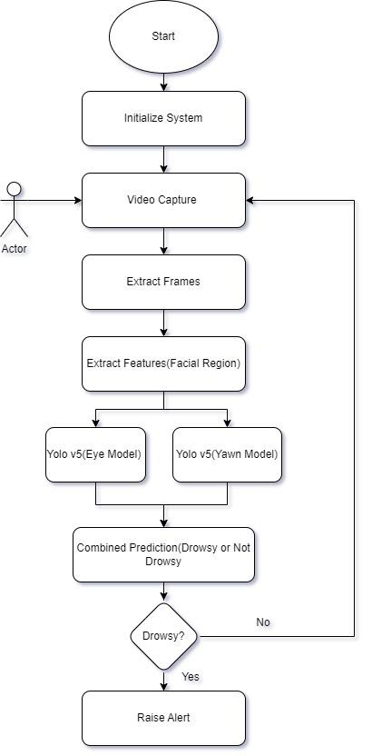

Fig.1 Proposed Design

The Proposed Design aims to achieve efficient and accurate predictions on full face images, utilizing various techniques and libraries to enhance the performance of the system.Initially, the system is initialized, and the user's video is captured using a webcam or an infrared camera to enhance the accuracy of detecting the region of interest, which is the facial region. Each frame of the video is extracted using the OpenCV cv2 library. Additionally, the dlib library is utilized for face detection within the image. Next, face alignment is carried out using the FaceAlignment class from the imutils.face_utils library to enhance the accuracy of eye and yawn detection. Furthermore, the background is blurred using a Gaussian blur technique. Subsequently, eyes and yawn detection are performed. In the preprocessing stage, the region of interest (ROI) within the image is extracted and passed to the model for prediction.The preprocessed frame is then fed into the model, which has been trained on 1200 images to predict the eyes and facial region. The output of each frame is saved using a counter. If the driver is determined to be drowsy based on a certain number of consecutive frames, the system will generate an alert to notify the driver of their drowsiness

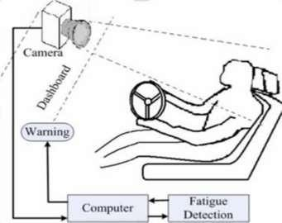

Fig.2 Architectural Design

* Input Image: The image or video containing the driver's facial region is given to the system to be evaluated. The image or video can be in any valid format. The input is then given to the Computer block
* Computer: The Computer involves the two Yolov5 model for each aspect of drowsiness detection and is trained on a 1200 image dataset and tested on a batch size of 60 to improve accuracy and not overfit the data
* Fatigue Detection: The process consists of a pipeline which preprocesses the image into various regions of interest such as region of mouth, eyes. Each segmented part of the equation is now fed to the previously trained Yolov5 model, which classifies the image as part of a specific class, recognizing what it is and returns the probability of belonging to that class.
* Output Generation/Warning: Once all outputs are recognized, the probabilities of classes are combined and a cumulative prediction will be given whether the person is drowsy or awake for that frame and thus if the output is persistent for a particular period of time the alarm will be raised.

## Chapter 5. RESULTS AND DISCUSSIONS

Following are the Results of the Model on various test cases

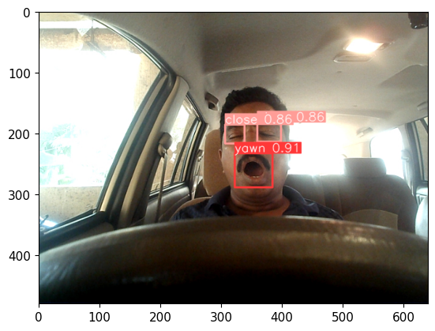

Fig.3 Driver Yawning

In Fig.3 the eyes of the driver are sufficiently closed for the model to classify it as closed and the mouth of the user is wide enough and the model detects it as a yawn. The probability of the classification is also defined which is further used in determining the driver’s drowsiness

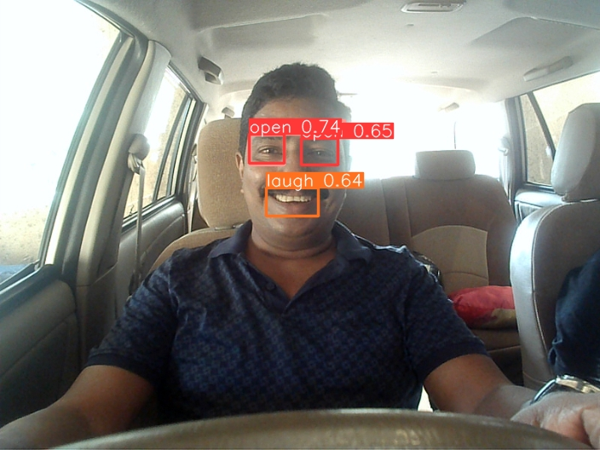

Fig.4 Driver Laughing

In Fig.4 the eyes of the driver are open for the model to classify it as open and the mouth of the driver is wide enough but since it is trained on dataset which could differentiate yawn from laugh and the model detects it as a laugh instead of a yawn. The probability of the classification is also defined which is further used in determining the driver’s drowsiness

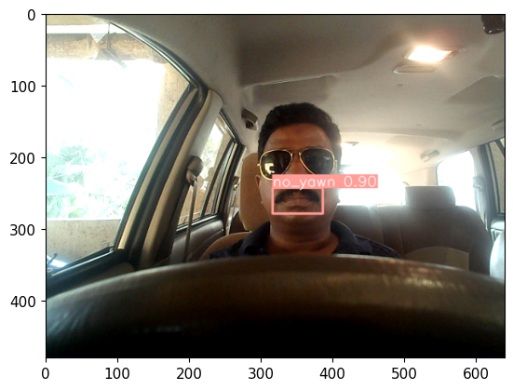

Fig.5 Driver with Shades

In Fig.5 the eyes of the driver are not predicted as the yolov5 is not able to detect the eyes region in the frame as the driver is wearing shades but it does detect the mouth region and gives a probability of the classification of the yawn.

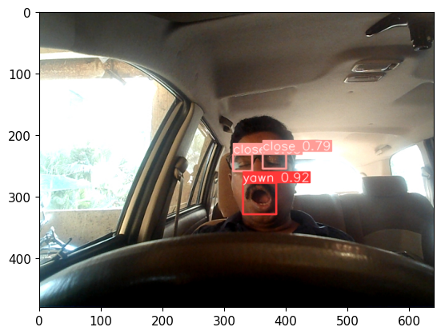

Fig.6 Driver with Glasses

In Fig.6 the eyes of the driver are visible through the Glasses therefore even though yolov5 is not trained on these images it is stable able to detect the eyes region in the frame and give the correct classification with a high probability.

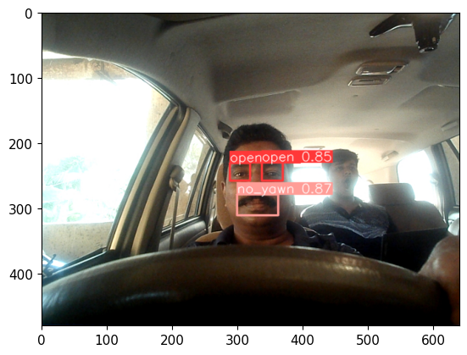

Fig.7 Driver along with passenger behind Yawning

In Fig.7 the model only gives the probability for the driver face and not the passenger sitting behind even though the passenger sitting behind is yawning. This happens because of the preprocessing done on the frame which is Gaussian Blur and Haar Cascade face filters which detects only the most probable face in the frame and removes the noise.

# Chapter 6. Conclusion

In conclusion, the driver drowsiness detection project using YOLOv5 has demonstrated the potential to effectively identify and alert drowsy drivers. By analyzing images or video streams captured by a camera, the system preprocesses the input, including resizing, background blurring, and face alignment. The regions of interest, specifically the mouth and eyes, are then extracted and passed through the YOLOv5 Model for classification. The model provides probabilities for each aspect, allowing for accurate determination of driver drowsiness.

The project's success in detecting drowsiness in real-time scenarios can greatly contribute to road safety and accident prevention. By sounding an alarm when drowsiness is detected, immediate action can be taken to ensure the driver's alertness or prompt them to take necessary breaks. This technology has the potential to save lives and minimize the risks associated with drowsy driving.

Although the project has shown promising results, there are areas for potential improvement. Further optimization of the preprocessing techniques and fine-tuning of the YOLOv5 Model can enhance the accuracy and efficiency of drowsiness detection. Additionally, integrating the system with other driver-assistance technologies and implementing real-time monitoring features can provide a comprehensive solution for driver safety.

Overall, the driver drowsiness detection project using YOLOv5 has successfully demonstrated the effectiveness of utilizing deep learning and computer vision techniques in identifying drowsy drivers. With further advancements and refinement, this technology can contribute significantly to reducing road accidents caused by driver fatigue and ensure safer journeys for all.

# Chapter 7. REFERENCES

1. Xiao, F.; Bao, C.Y.; Yan, F.S. Yawning detection based on gabor wavelets and LDA March 2009 Beijing Gongye Daxue Xuebao / Journal of Beijing University of Technology
2. Yin, B.-C.; Fan, X.; Sun, Y.-F. Multiscale dynamic features based driver fatigue detection Int. J. Pattern Recognit. Artif. Intell.
3. Akin, M.; Kurt, M.; Sezgin, N.; Bayram, M. Estimating vigilance level by using EEG and EMG signals. Neural Comput. Appl
4. Khushaba, R.N.; Kodagoda, S.; Lal, S.; Dissanayake, G. Driver drowsiness classification using fuzzy wavelet-packet-based feature extraction algorithm..
5. Hu, S.; Zheng, G. Driver drowsiness detection with eyelid related parameters by support vector machine
6. Lew, M.; Sebe, N.; Huang, T.; Bakker, E.; Vural, E.; Cetin, M.; Ercil, A.; Littlewort, G.; Bartlett, M.; Movellan, J. Drowsy driver detection through facial movement analysis. In Human Computer Interaction; Springer: Berlin, Germany,
7. Shen, W.; Sun, H.; Cheng, E.; Zhu, Q.; Li, Q. Effective driver fatigue monitoring through pupil detection and yawing analysis in low light level environments. Int. J. Digit. Technol. Appl.
8. Liu, J.; Zhang, C.; Zheng, C. EEG-based estimation of mental fatigue by using KPCA-HMM and complexity parameters. Biomed. Signal
9. Sharma, R., & Vatsa, M. (2017). A review of driver drowsiness monitoring systems. Journal of Ambient Intelligence and Humanized Computing, 8(4), 627-64
10. Qu, X., Wang, C., Hong, W., & Li, Y. (2019). Driver drowsiness detection using machine learning: A review. IEEE Access, 7,
11. Mehranian, A., & Moradi, M. H. (2019). Real-time drowsiness detection system for drivers: A comprehensive review. IET Intelligent Transport Systems,
12. Pattanaik, S. K., Ghosh, P., & Roy, P. P. (2018). A survey on drowsy driver detection systems. IETE Technical Review,
13. Li, S., Zhang, Y., & Wang, Y. (2019). Driver drowsiness detection: A survey. Pattern Recognition Letters
14. Sun, Y., Yang, J., & Zhang, C. (2019). Drowsiness detection for driving safety: A survey. IEEE Transactions on Intelligent Transportation Systems
15. Ba, H. Q., & Tuan, N. D. (2020). A comprehensive review on driver drowsiness detection systems. Information Fusion,
16. Wang, X., Li, X., Zhu, Y., & Shi, L. (2020). Driver drowsiness detection system: A review of recent developments and future prospects
17. Alhichri, H., & Brémond, F. (2019). Driver Drowsiness Detection: A Review of Recent Systems and Technologies. Sensors,
18. Li, C., Zhang, Y., & Zhang, G. (2020). A Novel Driver Drowsiness Detection System Based on EEG and Peripheral Physiological Signals. IEEE Access, 8, 224419-224428
19. Zhang, J., Song, S., He, W., & Wu, J. (2021). Driver Drowsiness Detection Using Multi-Modal Deep Learning. IEEE Access, 9, 20271-20280.
20. Olmos, S., Villalobos, W., Cazzato, D., & De Stefano, M. (2020). Real-time driver drowsiness detection based on eye tracking and face monitoring. Pattern Recognition,
21. Singh, S., Jain, A., & Sharma, R. (2021). Driver Drowsiness IEEE Transactions on Intelligent Transportation Systems
22. Trivedi, M. M., Rathi, S., Koshorekumar, A., & Chandra, A. (2020). Real-Time Drowsiness Detection Based on Blink Frequency Estimation Using Head-Pose Data. IEEE Transactions on Intelligent Transportation Systems
23. Li, Y., Tang, Y., Jiang, Z., Zhang, J., & Luo, S. (2021). Driver Drowsiness Detection Using Multi-Modal Deep Learning with Transfer Learning
24. Navaz, A., & Aljaaf, A. J. (2021). Driver Drowsiness Detection using Multi-Modal Features: A Deep Learning Approach. In 2021 International Conference on Internet of Things and Intelligence System (IoTaIS)
25. Kanchan, V., & Rautaray, S. S. (2021). Driver Drowsiness Detection using Deep Learning and YOLO Framework. In 2021 11th International Conference on Cloud Computing, Data Science & Engineering (Confluence) (pp. 253-257). IEEE.
26. Nyein, Y. Y. L., Aung, M. S. M., & Htet, W. W. (2020). Real-Time Drowsiness Detection System for Drivers Using YOLO Algorithm. In 2020 6th International Conference on Advanced Computing and Communication Systems (ICACCS) (pp. 1507-1511). IEEE
27. Shereef, S. A., Fahmy, M. H., & Abd El-Samie, F. E. (2020). Drowsiness Detection System using YOLO Algorithm. In 2020 22nd International Conference on Transparent Optical Networks (ICTON) (pp. 1-4). IEEE.
28. Orban, P., Raouzaiou, A., Karpouzis, K., & Kollias, S. (2013). Detecting laughter and yawning in spontaneous spoken interactions for automatic human affect recognition. Image and Vision Computing
29. Yazdani, S., Chen, F., & Dhall, A. (2021). SMILY: A Spontaneous Multimodal Laughter and Yawning Dataset for Automatic Detection and Classification. In Proceedings of the 2021 International Conference on Multimodal Interaction
30. Canavan, S., Lucey, P., & Tzimiropoulos, G. (2020). Learning discriminative and shareable features for laughter and yawning detection. In Proceedings of the IEEE/CVF Conference on Computer Vision and Pattern Recognition Workshops